Parks and Green Spaces
Monthly Inspection Example
EXAMPLE PARK
Month/Year:

Date of inspection: |  | Signed:
Staff member (1):
Staff member (2):
Items referred to (Asset Department) / (External Contractor) for repairs:

General comments/observations/recommendations:

Items for Managers attention:

Manager name: |  | Signed:
Date checked:
Manager’s comments:

Park environment, infrastructure and street furniture
Mark walk route on map below (this declares that the whole site has been checked)
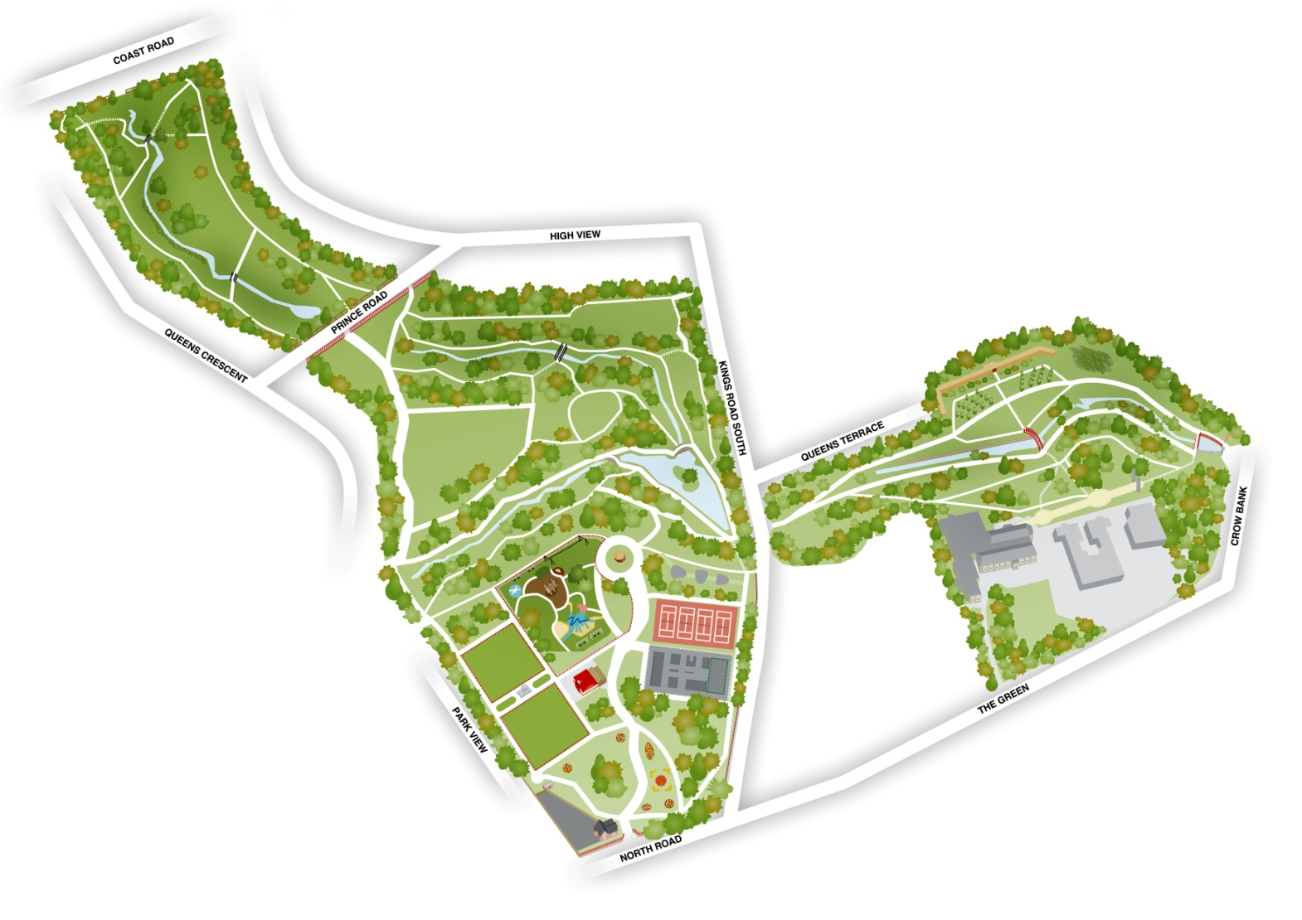

Park environment, infrastructure and street furniture
Environment |  |  | Further action:
Is the tree canopy above footpaths free of dead, dying, diseased or loose branches?
Is the tree canopy above surrounding pavements/roads free of dead, dying, diseased or loose branches?
Are all footpaths clear of overhanging vegetation / branches that could make contact at head height or below?
Are all invasive or poisonous plant species identified with the team and either cordoned off, due to be removed or on a treatment plan?
Have all known hotspots been checked for sharps/needles/drug paraphernalia or broken glass?
Infrastructure |  |  | Further action:
Are footpaths in safe condition and free of trip hazards?
Are steps in safe condition and free of trip hazards?
Are bridges in safe condition with no visible subsidence of the balustrades, walking surfaces safe and railings securely fitted?
Is fencing and gates in a safe condition with no gaps, sharp edges or protruding fixings?
Are culvert grills safe, clear, adequately fixed and free flowing.
Street furniture |  |  | Further action:
Are the benches safe to sit on with no cracks or visible sign of damage? Are the legs free from cracks and have no visible sign of damage?
Are the bins set in the ground correctly? Are the wooden frames free from visible signs of damage? Does the bin have a liner in?
Are the lampposts structurally sound, free of paint damage and access hatch securely fastened?
Are the feeder pillars free of paint damage, structurally sound and door secure and locked? Is the earthing block present and secure?
Are CCTV camera poles structurally sound, free from paint damage? Are the cameras/LED units damaged at all?
Are the bowling green ramps and steps securely fastened down without trip hazards? Do they have visible signs of wear?
Park signage |  |  | Further action:
Are water safety warnings visible and free of surrounding vegetation?
Are the fence notice boards in a safe condition with no damage, securely fastened, with no sharp edges or protruding fixings?
Interpretation lecterns safe as above? Are they clearly eligible and free of graffiti?
Upright notice boards/interpretation safe as above? Are they clearly eligible and free of graffiti?
Opening times checked as above?
Entry signs checked as above?
Fire assemble points present and are the signs visibly clear and in correct position?
Vehicle restrictions - are they in the correct place and are clear to read?
Service yard site safety signages - are they in the correct place and are clear to read?

Monuments features and sculptures |  |  | Further action:
Are the tree sculptures structurally sound? (Test with force) Are they free from damage/graffiti? Is the key visibly secured with the original cables?
Is the Duffy Memorial structurally sound and free from damage/graffiti? Are there any chipped edges?
Is the Boat seat structurally sound and free from damage and trip hazards?
Is the bandstand structurally sound and free damage? Are the railings secure?
Are the Promenade pillars structurally sound and visibly clear of any damage/graffiti?
Is the Vinery Wall structurally sound: free from bowing, large mortar cracks, loose or missing bricks or copings.
Is the fernery structurally sound and visibly clear of any damage as above? Is the gate secure?
Sports & Play Facilities
Are tennis court surfaces, signage, nets and fencing, gates and surrounds safe and in good condition?
Are MUGA surfaces, signage, fencing, gates and surrounds, goalmouths, basketball hoops & cricket stumps safe and in good condition?
Are Outdoor Gym surfaces, signage and equipment safe and in good condition?
Are Play Area landscape features: Tunnel doors, mound, teen shelter, fencing, trees and vegetation safe and in visibly good condition?
Is the water system chamber lid secure, is the system functioning?
Are games greens fencing, surrounds, gates and surfaces safe and free from damage or deterioration? Has the irrigation system been tested recently?
Additional notes:

Buildings and surrounding areas

Externals of buildings |  |  | Further action:
Are building roofs in a good condition with no missing tiles or lead?
Are building walls in a good condition? (Timber cladding, brick, plaster)
Are gutters. Downpipes and surface water drains visibly clear?
Are manholes sitting flush and secure to the frame? Is drainage from buildings free from issues?
External access and egress: |  |  | Further action:
Are all access routes kept clear of combustible materials?
Are external access and exit routes clear, in good order and free from trip and slip hazards?
Hazardous substances: |  |  | Further action:
Are all hazardous substances (cleaning chemicals, pesticides etc.) correctly stored?
Are hazardous substances restricted from access by unauthorised persons?
Are plant rooms, cleaner's cupboards, and stores kept locked?
External Areas: |  |  | Further action:
Are structures i.e. sheds, containers and external storage in good repair and secure?
Are fragile roofs adequately safeguarded and signed?
Are adjoining walls and fences and gates in good condition?
Are service yard materials stored safely and secure? Are walking/driving surfaces free from slip/trip/puncture hazards?

Welfare Facilities: |  |  | Further action:
Are there adequate and clean sanitary provisions?
Is drinking water readily available?
Are there provisions for employees to make a hot drink?
Are there adequate facilities for staff to take breaks and eat meals?
First Aid: |  |  | Further action:
Do you have a properly stocked First Aid Box?
Has the first aid box in: Park Lodge front door, Park Lodge rear, Machinery Store, Community Kitchen, Café been checked and restocked if necessary?
Do you have someone who ensures the First Aid Box is kept to minimum levels for agreed contents?
Fire Safety Measures: |  |  | Further action:
Are there clear instructions for fire and emergency actions in all buildings?
Do you have a robust and effective written fire emergency evacuation plan?
Has this plan been reviewed and where necessary updated within the last 12 months?
Has a monthly fire alarm test been carried out including checks to fire escapes?
Is the access system releasing door magnets during a fire alarm?
Are the machinery store shutters automatically closing during a fire alarm?
Indoor Environment: |  |  | Further action:
Is workplace sufficiently well ventilated?
Is workplace temperature reasonably comfortable?
Is lighting adequate?
Is inhalable dust and noise below work exposure levels.
Indoor floors, Walkways & Stairs: |  |  | Further action:
Are all floors and walkways clear and in good condition and free of slip/trip hazards?
Are steps and stairways safe and in good condition and fitted with adequate handrails?
Are external walkways/routes/veranda free of potholes/trip hazards?
Internal access and Egress: |  |  | Further action:
Are all access routes kept clear of combustible materials?
Are all exit routes unlocked and clear of any obstructions?
Are external access and exit routes clear, in good order and free from trip and slip hazards?
CCTV System and Security: |  |  | Further action:
Are the CCTV presets still operating correctly?
Are all cameras functioning correctly and free from visual obstruction?
Is the building access system working correctly? Are all mag-locks working?
Additional notes:

