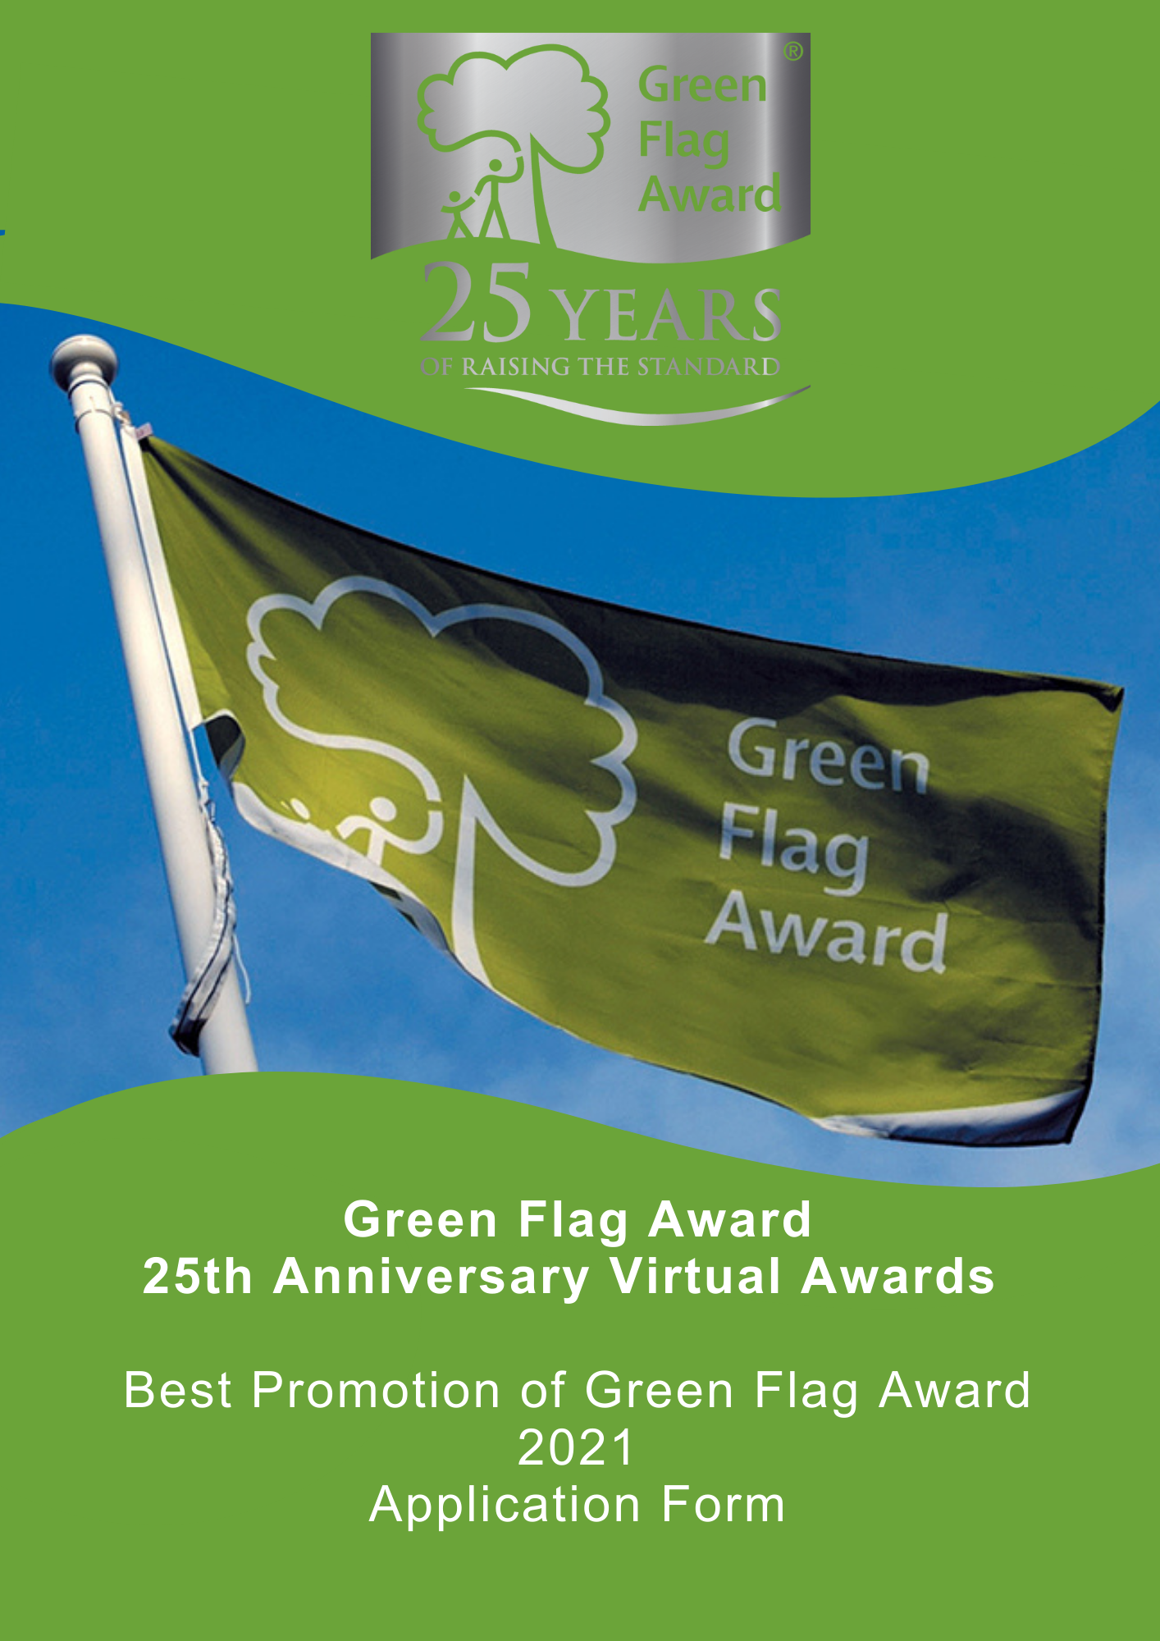

The Green Flag Award Scheme is the UK standard for parks and green spaces. The Scheme is delivered in the UK by Keep Britain Tidy, Keep Northern Ireland Beautiful, Keep Scotland Beautiful and Keep Wales Tidy.
2021 marks the 25th anniversary of the Green Flag Award scheme, and in celebration of this occasion we are hosting a virtual award ceremony in November 2021.
Nominees will be shortlisted in October 2021 and the winner will be announced during the virtual award ceremony, date TBC.

Award Category: Best Promotion of Green Flag Award
Eligibility
Any one of the Green Flag Award or Green Flag Community Award winning sites in the UK can apply for this award. The application must be submitted by the management team of the space.
Criteria
The following criteria will be considered by the selection panel:
- Any initiative, event, provision or otherwise that has been developed and implemented to celebrate achieving a Green Flag Award / Green Flag Community Award
- The potential number of beneficiaries will be considered
- The sustainability, scalability and replicability of the initiative will be considered
- Innovative and new ideas
- Nominations must be submitted electronically and address the criteria for the award. Organisations may nominate more than one initiative. Please complete a separate nomination form for each initiative.
Applicants must agree to any media publicity and promotion associated with the award as requested by The Green Flag Award Scheme and or Keep Britain Tidy and their partners.

Selection Panel
Applications will be assessed by an independent selection panel chaired by the Green Flag Award Team.
The judges reserve the right not to confer an award.
Award
The panel will award a winner, or in a tie, may award joint winners of the award. In exceptional circumstances the panel may confer a special commendation.
Feedback
The selection panel will provide feedback for the winner of the award. No feedback will be provided to unsuccessful applications
If you would like to send us supporting evidence such as reference materials, photos, screen grabs or press cuttings, please send these with the completed application form to greenflagawards@keepbritaintidy.org
CLOSING DATE FOR ENTRIES: Wednesday 22nd September (1pm)

Part One:
Project and applicant Information
Name and contact details of person completing the application

Name of Green Flag Award site

Date(s) the initiative was live?

Please complete each of the sections below, using maximum 500 words per section and identify any supporting evidence you are submitting.

Part Two:
Application Details
Please describe the event / activity to promote Green Flag Award?
(Maximum 500 words, please identify any supporting evidence you are submitting.)

For what purpose was the initiative developed? Which groups within the community does it target?
(Maximum 500 words, please identify any supporting evidence you are submitting.)

Describe what impact and benefit the initiative made to the community.
(Maximum 500 words, please identify any supporting evidence you are submitting.)

Describe the benefits of the promotion; e.g. increased levels of awareness, more visitors etc.
(Maximum 500 words, please identify any supporting evidence you are submitting.)

Thank you for submitting your application.

