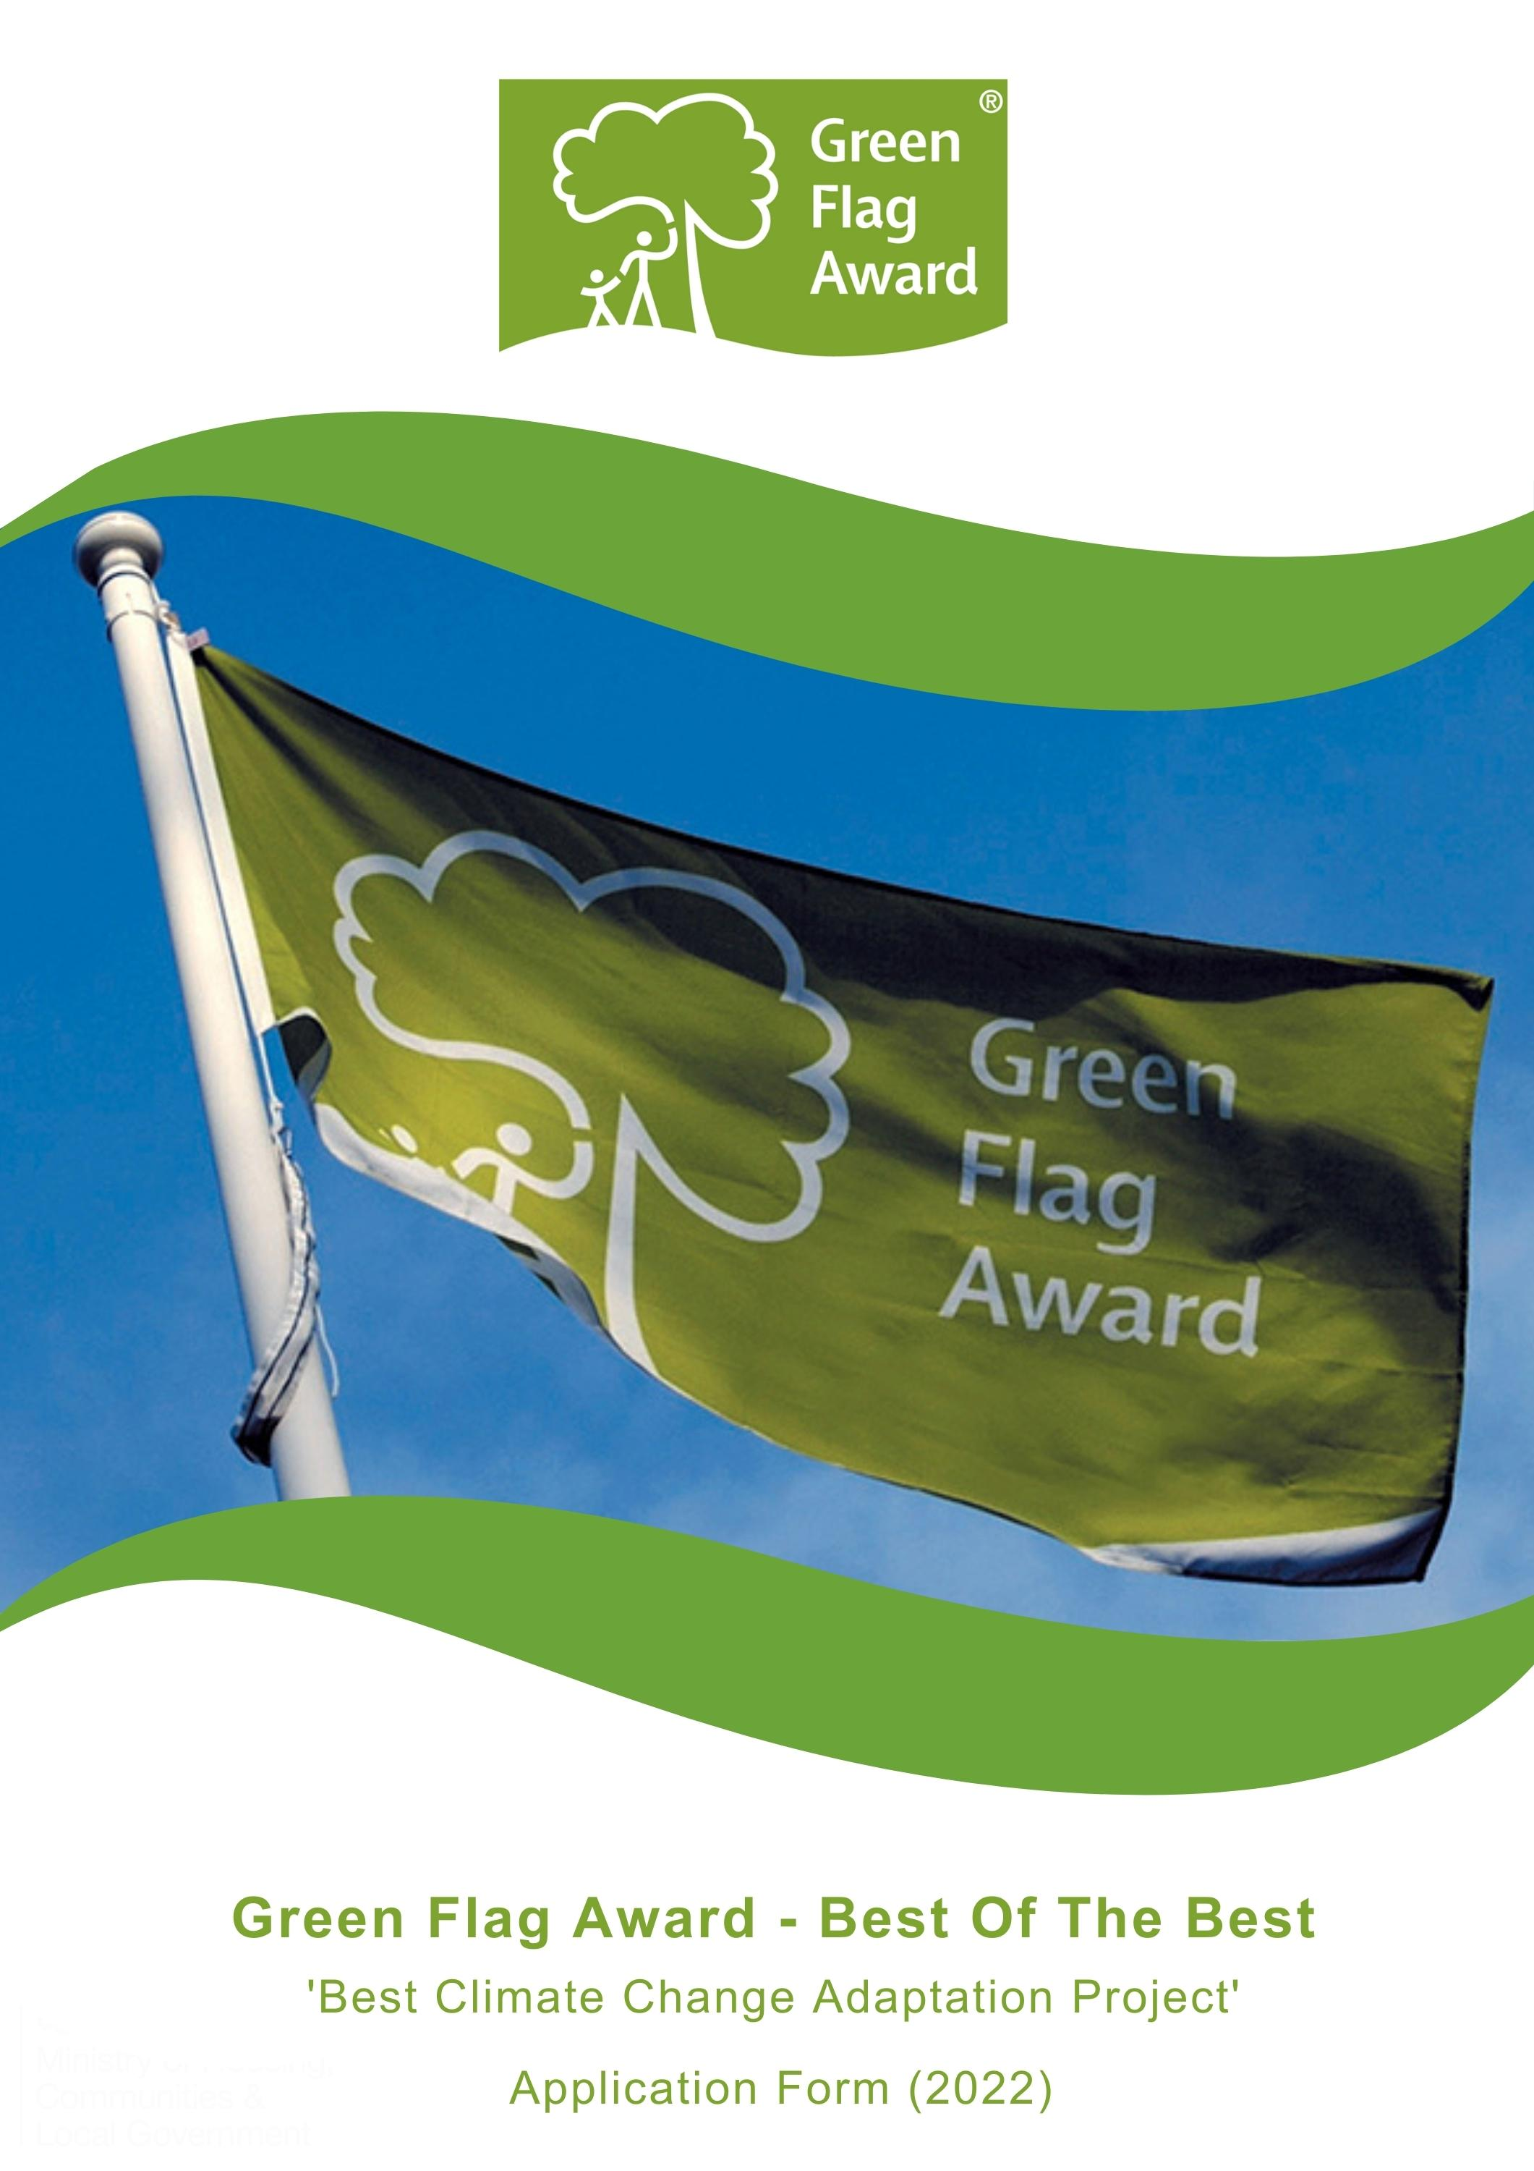

The Green Flag Award Scheme is the UK standard for parks and green spaces. The Scheme is delivered in the UK by Keep Britain Tidy, Keep Northern Ireland Beautiful, Keep Scotland Beautiful and Keep Wales Tidy.
To highlight the amazing work that takes place in our award-winning green spaces we are celebrating the ‘Best of the Best’ in our annual virtual award ceremony this November.
Nominees will be shortlisted in October 2022 and the winner will be announced during the virtual award ceremony, on Tuesday 15th November 2022.
This award is supported by players of People’s Postcode Lottery.

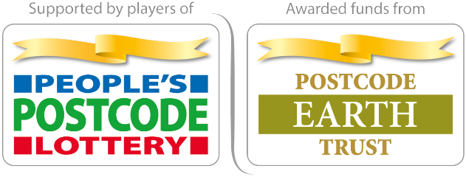

Award Category: Best Climate Change Adaptation Project
Eligibility
Any one of the Green Flag Award or Green Flag Community Award winning sites in the UK can apply for this award, or project that sits adjacent to an awarded green space. The application must be submitted by the management team of the space.
Criteria
The following criteria will be considered by the selection panel:
- Any project that has been developed and implemented in an awarded green space or is adjacent to, or connects green spaces
- The potential number of benefits will be considered – e.g. flood management, habitat creation, reduction / elimination of fossil fuels, biodiversity, energy consumption etc
- The sustainability, scalability and replicability of the initiative will be considered
- Innovative and new ideas
- Nominations must be submitted electronically and address the criteria for the award. Organisations may nominate more than one initiative. Please complete a separate nomination form for each initiative.
Applicants must agree to any media publicity and promotion associated with the award as requested by The Green Flag Award Scheme and or Keep Britain Tidy and their partners.
Selection Panel
Applications will be assessed by an independent selection panel chaired by the Green Flag Award Team.
The judges reserve the right not to confer an award.

Award
The panel will award a winner, or in a tie, may award joint winners of the award. In exceptional circumstances the panel may confer a special commendation.
Feedback
The selection panel will provide feedback for the winner of the award. No feedback will be provided to unsuccessful applications
If you would like to send us supporting evidence such as reference materials, photos, screen grabs or press cuttings, please send these with the completed application form to greenflagawards@keepbritaintidy.org
CLOSING DATE FOR ENTRIES: Friday 30th September by 5pm

Part One:
Project and applicant Information
Name of nominated project (if applicable)

Name of Green Flag Award site

Contact details for nominated site
Name, address, tel, email

Name and contact details of person and organisation nominating the site

Please complete each of the sections below, using maximum 500 words per section and identify any supporting evidence you are submitting.

Part Two:
Application Details
Please describe the climate change adaptation project?
(Maximum 500 words, please identify any supporting evidence you are submitting.)

What is the aim of the project? How does it demonstrate adaptation to a changing climate?
(Maximum 500 words, please identify any supporting evidence you are submitting.)

Describe what impact and benefit the project has made.
(Maximum 500 words, please identify any supporting evidence you are submitting.)

How have you communicated the benefits of this project to the users of the space?
(Maximum 500 words, please identify any supporting evidence you are submitting.)

Thank you for submitting your application.

