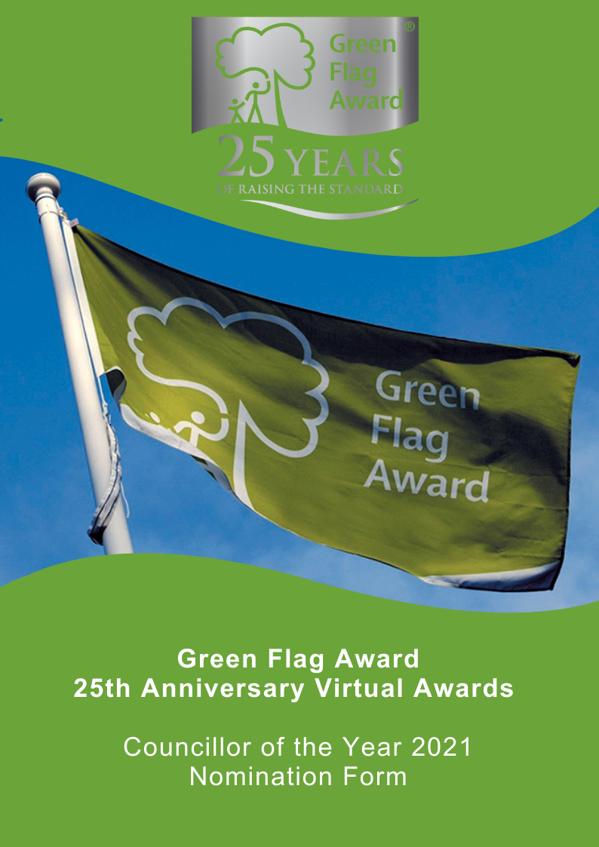

The Green Flag Award Scheme is the International standard for parks and green spaces. The Scheme is delivered in the UK by Keep Britain Tidy, Keep Northern Ireland Beautiful, Keep Scotland Beautiful and Keep Wales Tidy.
2021 marks the 25th anniversary of the Green Flag Award scheme, and in celebration of this occasion we are hosting a virtual award ceremony in November 2021.
Nominees will be shortlisted in October 2021 and the winner will be announced during the virtual award ceremony, date TBC.

Award Category: Green Flag Award Councillor of the Year
Eligibility
Any elected councillor who has supported one or more of the Green Flag Award winning sites in the UK or has made a significant contribution to parks and green spaces within the authority to which they are elected.
Who can be nominated?
To be eligible for an award, the councillor must currently be in office and be making a positive impact in park and green spaces within their authority.
Who can nominate?
Any individual is entitled to nominate any number of Councillors. However, any nomination must be endorsed by the organisation for which the Councillor has been elected.
Criteria
The following criteria will be considered by the selection panel:
- Scope of the work undertaken and the outcome of their involvement
- Initiative and innovation demonstrated by the Councillor
- The benefit their involvement has brought to the local community
- Any obstacles which the nominee may have had to overcome to achieve the outcomes of their involvement.
Nominations must be submitted electronically and address the criteria for the award. Organisations may nominate more than one Councillor.
Nominees must agree to any media publicity and promotion associated with the award as requested by The Green Flag Award Scheme and or Keep Britain Tidy and their partners.

Selection Panel
Nominations will be assessed by an independent selection panel chaired by the Green Flag Award Team.
The judges reserve the right not to confer an award.
Award
The panel will award a winner, or in a tie, may award joint winners of the award. In exceptional circumstances the panel may confer a special commendation.
Feedback
The selection panel will provide feedback for the winner of the award. No feedback will be provided to unsuccessful applications
If you would like to send us supporting evidence such as reference materials, photos, screen grabs or press cuttings, please send these with the completed application form to greenflagawards@keepbritaintidy.org
CLOSING DATE FOR ENTRIES: Wednesday 22nd September (1pm)

Part One:
Project and applicant Information
Name of nominated Councillor

Contact details of nominated Councillor
Name, address, tel, email

Name and contact details of person and organisation nominating the Councillor

Name of Green Flag Award site

Name of person and organisation endorsing the nomination (if different to person making the nomination)

Please complete each of the sections below, using maximum 500 words per section and identify any supporting evidence you are submitting.

Part Two:
Application Details
What work did the Councillor undertake and what did they achieve?
(Maximum 500 words, please identify any supporting evidence you are submitting.)

Tell us about initiative and innovation demonstrated by the Councillor.
(Maximum 500 words, please identify any supporting evidence you are submitting.)

Describe what impact and benefit the individual has made in the course of their elected term.
(Maximum 500 words, please identify any supporting evidence you are submitting.)

Tell us about any obstacles which the nominee may have had to overcome to achieve the outcomes of their work.
(Maximum 500 words, please identify any supporting evidence you are submitting.)

Thank you for submitting your application.

