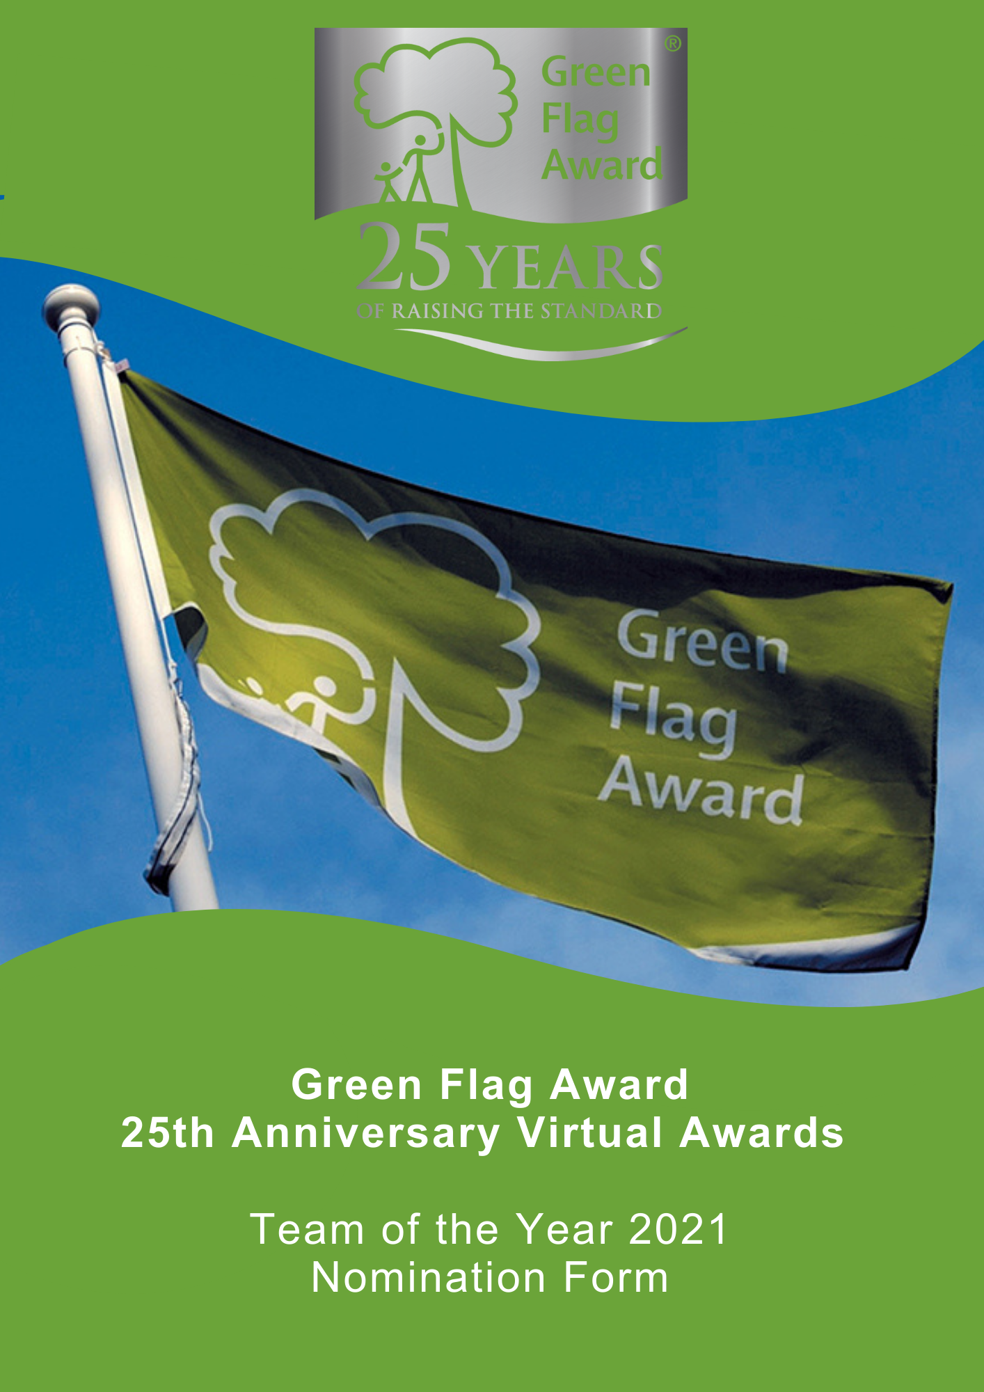

The Green Flag Award Scheme is the UK standard for parks and green spaces. The Scheme is delivered in the UK by Keep Britain Tidy, Keep Northern Ireland Beautiful, Keep Scotland Beautiful and Keep Wales Tidy.
2021 marks the 25th anniversary of the Green Flag Award scheme, and in celebration of this occasion we are hosting a virtual award ceremony in November 2021.
Nominees will be shortlisted in October 2021 and the winner will be announced during the virtual award ceremony, date TBC.

Award Category: Team of the Year 2021
Eligibility
Any team of park / green space employees or volunteers who work in a UK Green Flag Award park or green space.
Who can be nominated?
To be eligible for an award, the team must work for or volunteer for and be endorsed by the organisation for which they work or volunteer.
Who can nominate?
Any organisation is entitled to nominate.
Criteria
The following criteria will be considered by the selection panel:
- Scope of the work undertaken and the outcome of their work
- Initiative and innovation demonstrated by the team
- Impact and benefit the team has made in the course of their work
- Any obstacles which the team may have had to overcome to achieve the outcomes of their work.
Nominations must be submitted electronically and address the criteria for the award.
Nominees must agree to any media publicity and promotion associated with the award as requested by The Green Flag Award Scheme and or Keep Britain Tidy and their partners.
Selection Panel
Nominations will be assessed by an independent selection panel chaired by the Green Flag Award Team.
The judges reserve the right not to confer an award.

Award
The panel will award a winning team, or in a tie, may award joint winners of the award. In exceptional circumstances the panel may confer a special commendation.
Feedback
The selection panel will provide feedback for the winner of the award. No feedback will be provided to unsuccessful applications
If you would like to send us supporting evidence such as reference materials, photos, screen grabs or press cuttings, please send these with the completed application form to greenflagawards@keepbritaintidy.org
CLOSING DATE FOR ENTRIES: Wednesday 22nd September (1pm)

Part One:
Project and applicant Information
Names of nominated employees / volunteers

Contact details of nominated employees / volunteers
Name, address, tel, email

Name and contact details of person and organisation nominating the employees / volunteers

Name of Green Flag Award site

Please complete each of the sections below, using maximum 500 words per section and identify any supporting evidence you are submitting.

Part Two:
Application Details
What work did the team undertake and what did they achieve?
(Maximum 500 words, please identify any supporting evidence you are submitting.)

Tell us about initiative and innovation demonstrated by the team.
(Maximum 500 words, please identify any supporting evidence you are submitting.)

Describe what impact and benefit the team has made in the course of their employment / volunteering.
(Maximum 500 words, please identify any supporting evidence you are submitting.)

Tell us about any obstacles which the team may have had to overcome to achieve the outcomes of their work / volunteer activity.
(Maximum 500 words, please identify any supporting evidence you are submitting.)

Thank you for submitting your application.

